AWS Task-2
Task Description:
Set up a VPC with an Internet gateway, create a public subnet with 256 IP addresses, a private subnet with 256 IP addresses, make a route table connecting the Internet gateway and the subnets, and launch a Linux EC2 instance by using the above VPC and public subnet.
Step 1: Create VPC (Virtual private cloud)
- Login to AWS Management Console
- Search for VPC in the search bar
- Click Create VPC
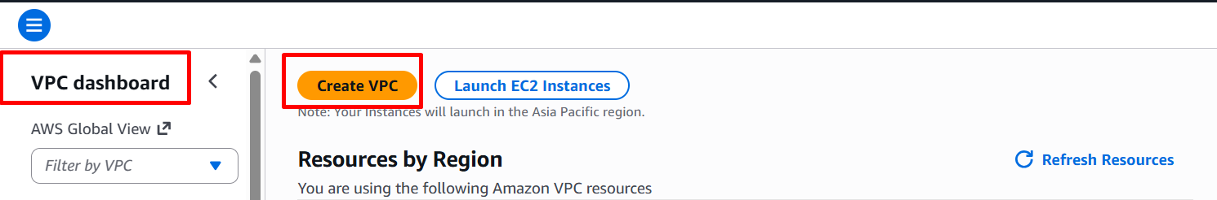
Configuration:
- Name: My-VPC
- IPv4 CIDR block: 10.0.0.0/16
- Tenancy: Default
- Click Create VPC
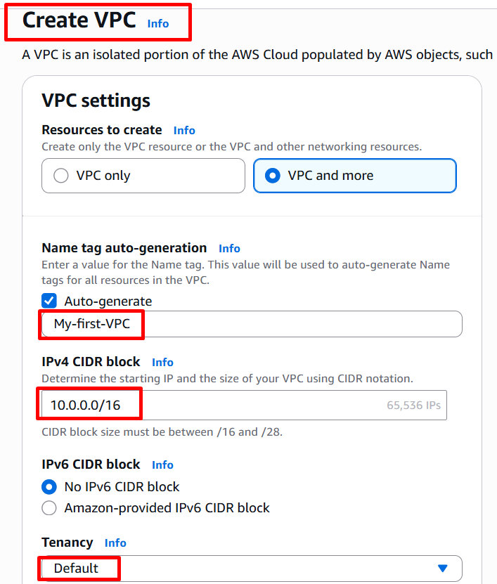

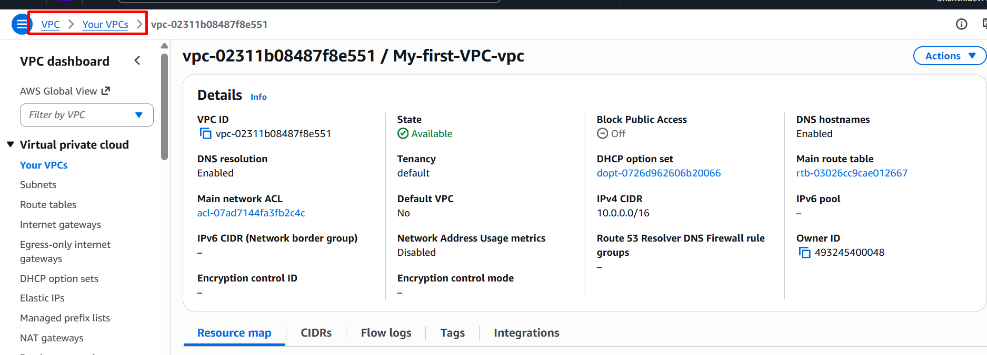
Step 2: Create Subnets
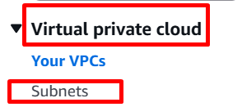
Public Subnet:
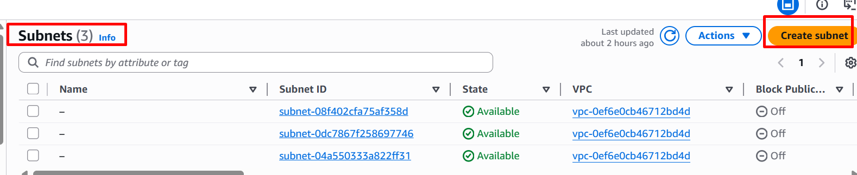
- Go to Subnets → Create subnet
- Select My-first-VPC-vpc
- Subnet name: Public-Subnet-first
- Availability Zone: ap-south-1b
- CIDR block: 10.0.1.0/24 (256 IPs)
- Click Create subnet

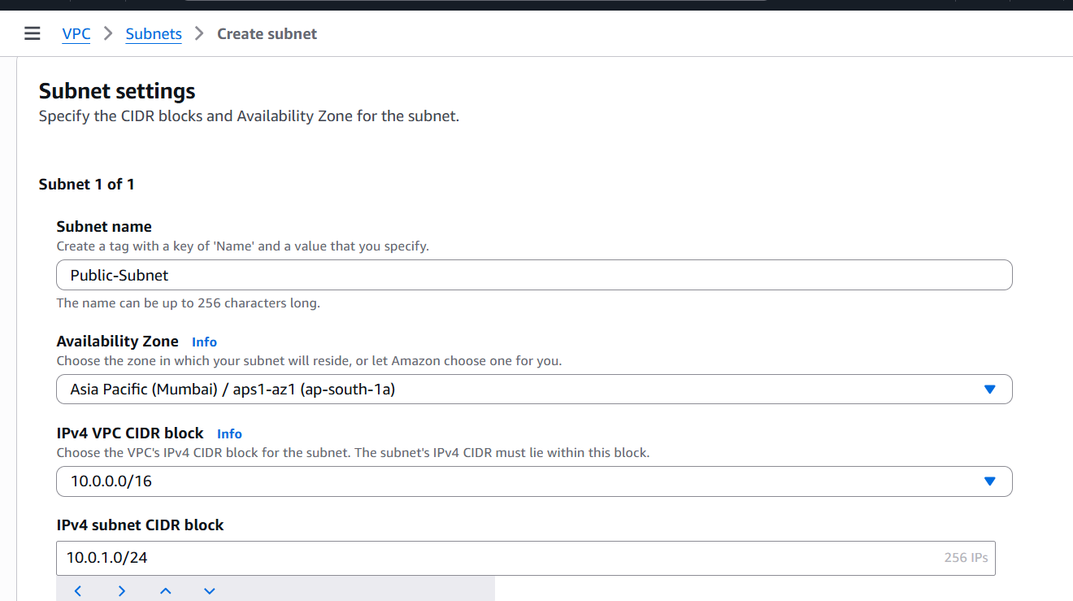
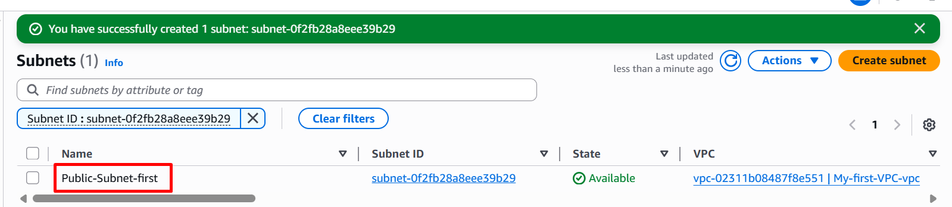

Private Subnet
Click Create subnet
Configuration:
- Name: Private-Subnet-first
- Availability Zone: ap-south-1b
- CIDR block: 10.0.2.0/24 (256 IPs)
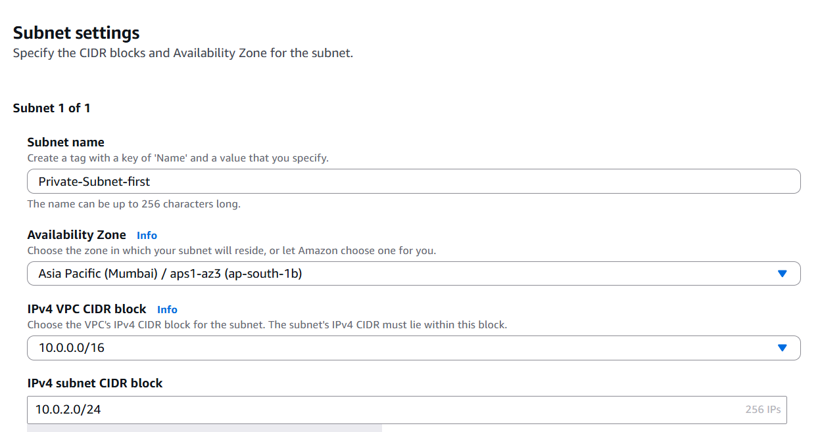
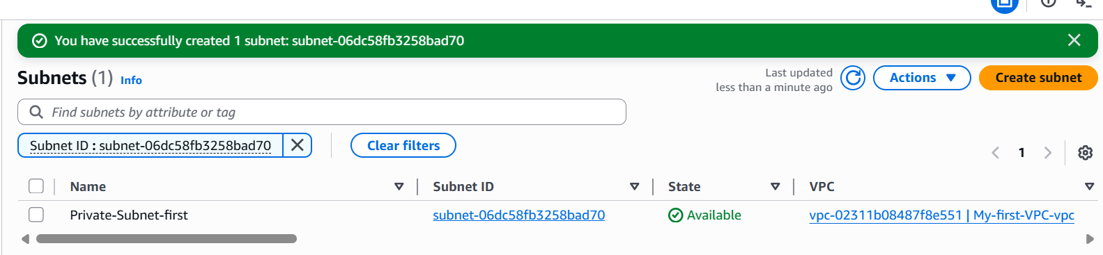

Step 3: Create Internet Gateway
- Go to Internet Gateways
- Click Create Internet Gateway
- Name: My-first-vpc-igw
- Click Create
- Attach to VPC: Select IGW → Attach to VPC
- Choose My-first-VPC

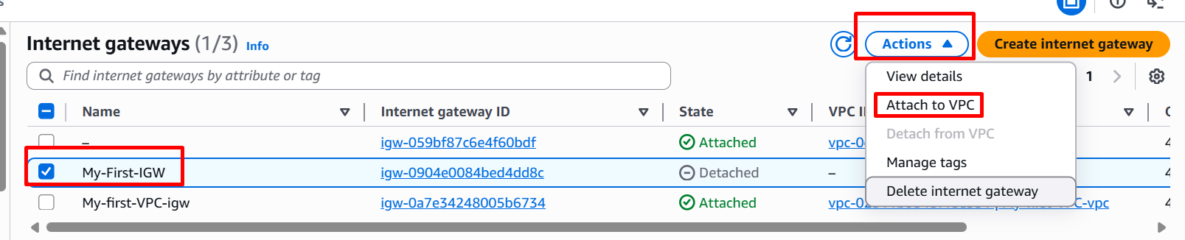
Step 4: Create Route Table (Public)
- Go to Route Tables
- Click Create Route Table
Configuration:
- Name: Public-RT-first
- VPC: My-first-VPC

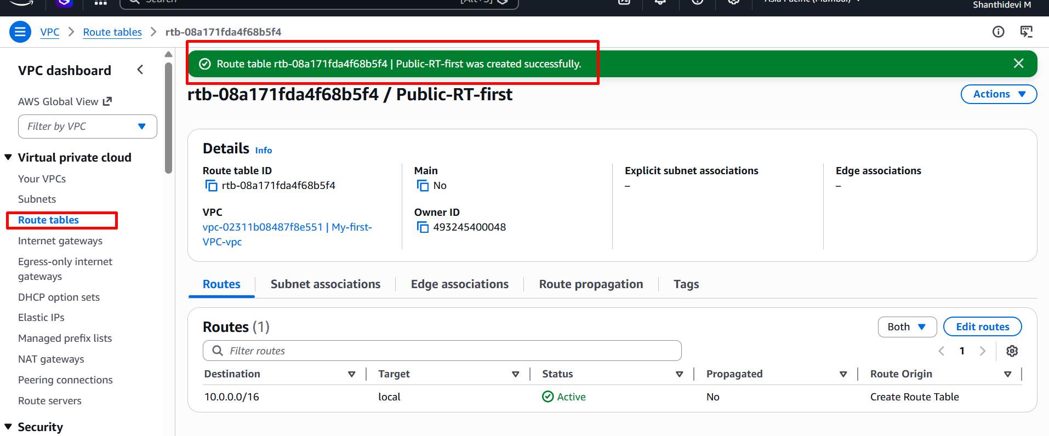

Add Route to Internet
- Select Public-RT
- Go to Routes → Edit routes
- Add:
- Destination: 0.0.0.0/0
- Target: My-IGW
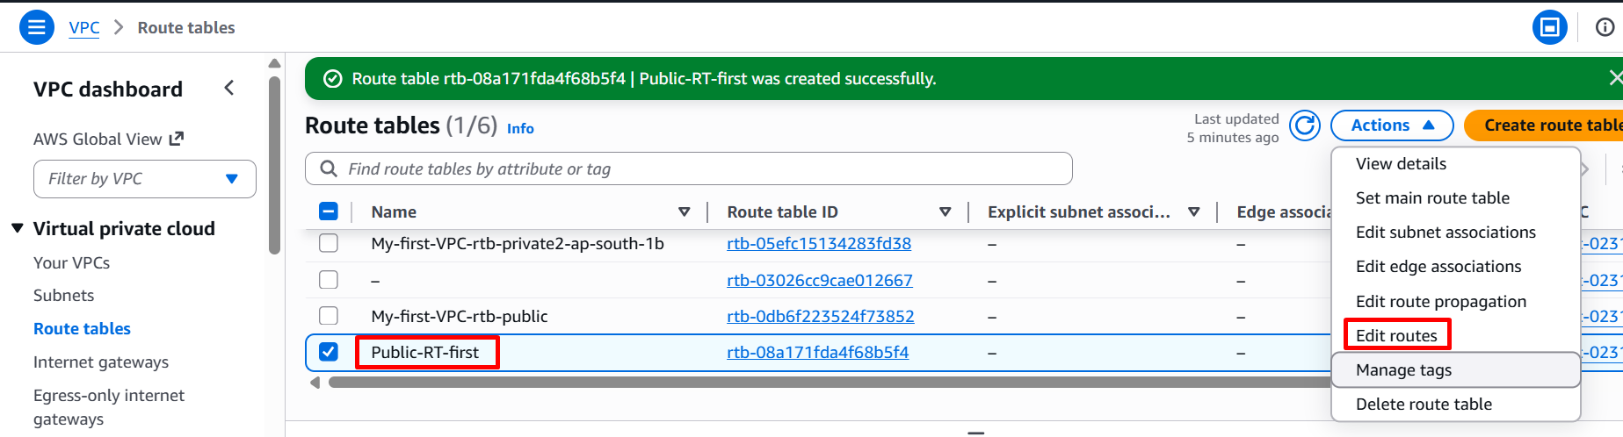
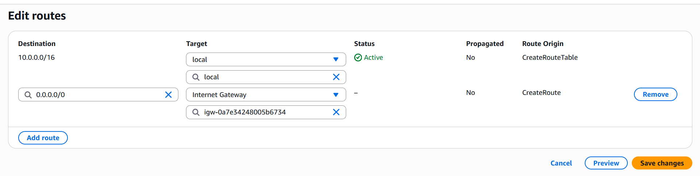
Associate Public Subnet
- Go to Subnet Associations
- Click Edit associations
- Select Public-Subnet
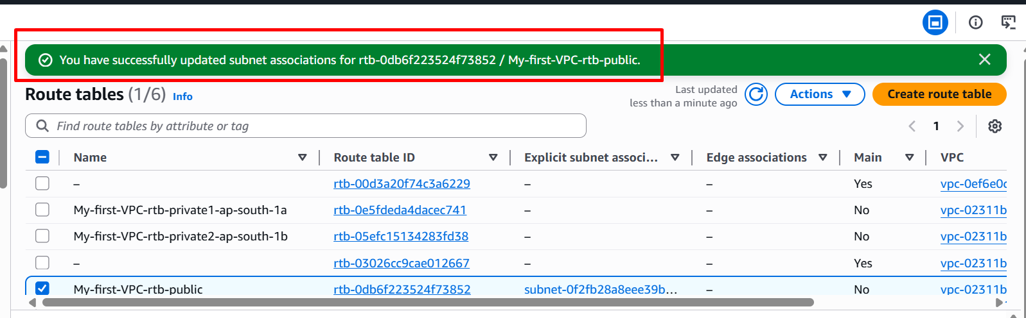

Step 5: Enable Auto-Assign Public IP
- Go to Subnets
- Select Public-Subnet
- Click Actions → Edit subnet settings
- Enable: Auto-assign public IPv4 address
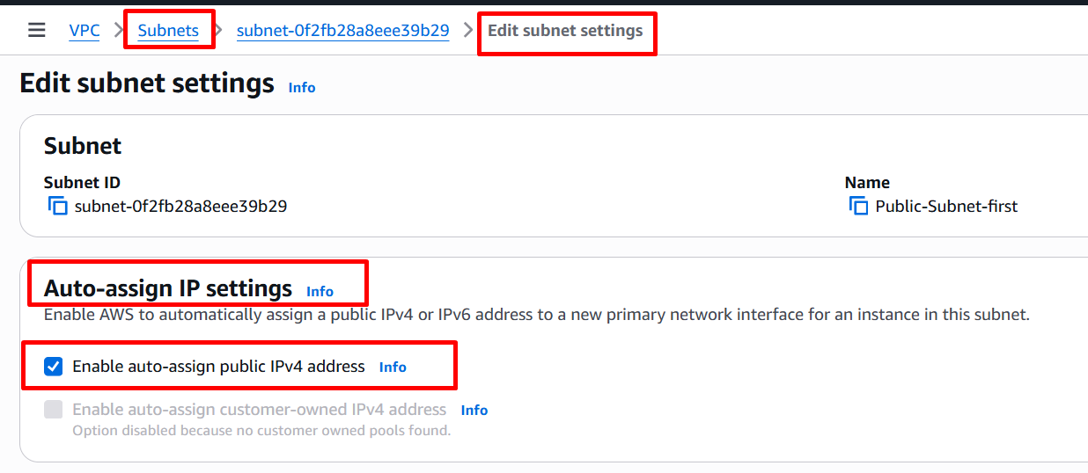

Step 6: Launch Linux EC2 Instance
- Go to EC2 Dashboard
- Click Launch Instance
- Name: Linux-first-instance
- AMI: Amazon Machine Image
- Instance type: t.micro (Free tier)
Key Pair:
- Create the Key pair
Network Settings:
- VPC: My-VPC
- Subnet: Public-Subnet
- Auto-assign Public IP: Enabled
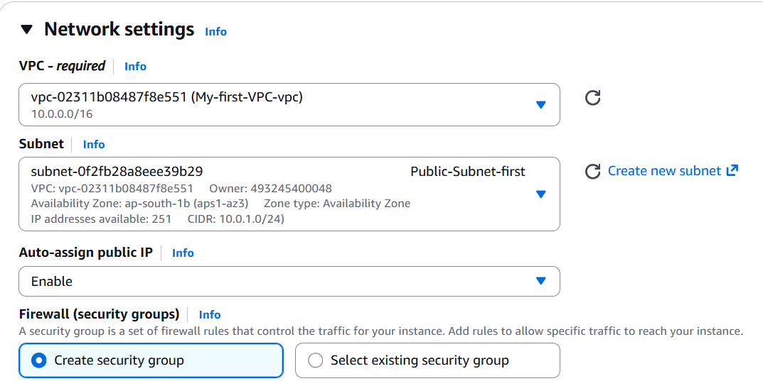
Security Group:
Allow:
- SSH (port 22) → My IP
- HTTP (port 80) → Anywhere
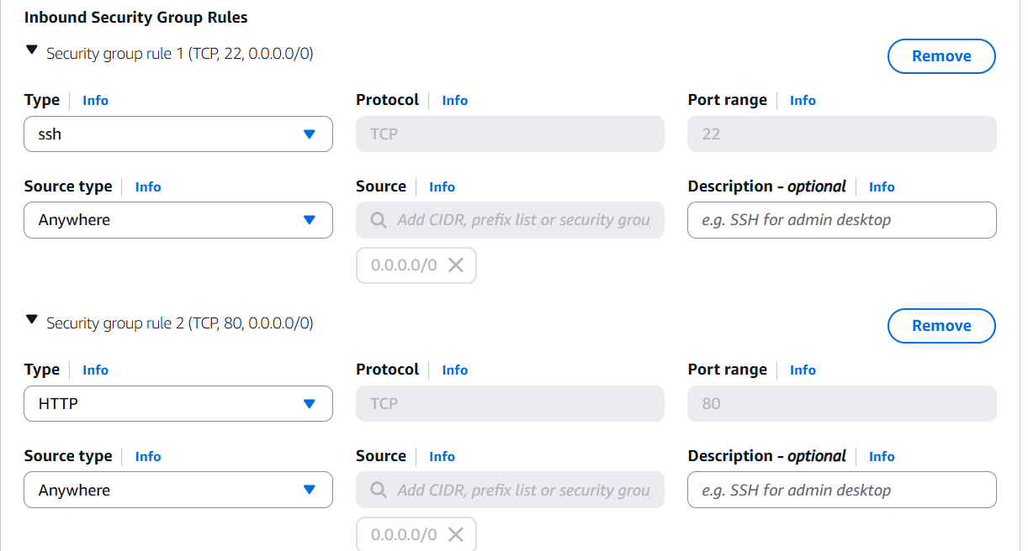

Click Launch Instance
Step 7: Connect to EC2

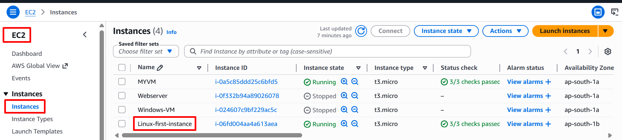

Use SSH Client:
ssh -i "linux-first.pem" ec2-user@ec2-3-7-46-125.ap-south-1.compute.amazonaws.com
Step 8: Verify Internet Access
ping google.com
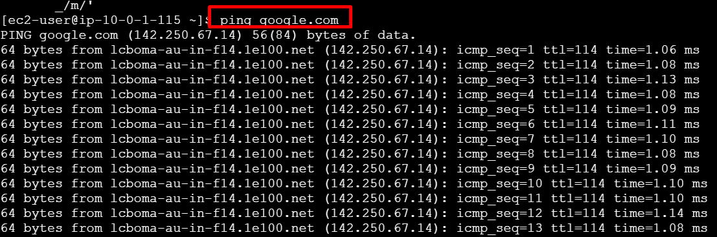
curl ifconfig.me
